**DATA ANALYSIS**

**MINI PROJECT**

**ANALYSIS OF INDIAN ELECTION**

**Questions:**

1)name the column totvotpoll to Votes_received. What are the total votes received by each political party for every election year?

**Solution:**

At the transform data , right click on the totvotpoll column, rename to votes_received.

**Output:**

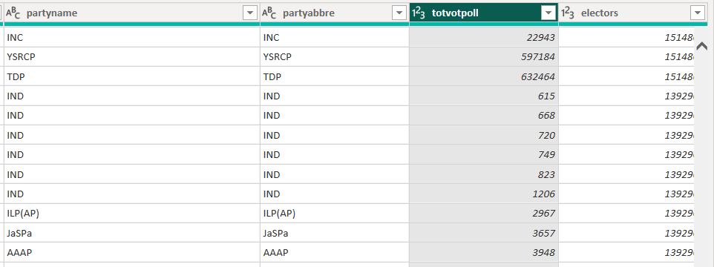

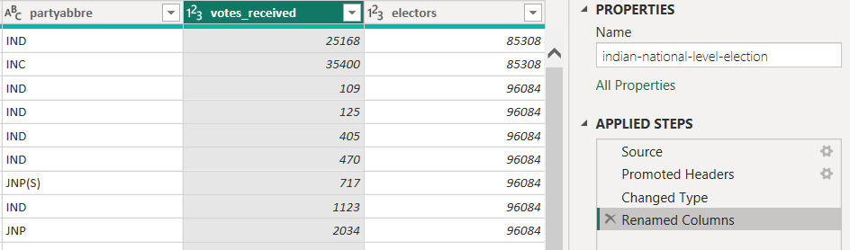

2) Which political party received the most votes in each year, and how did their performance change over the years?

**Solution:**

At the transform data , party name group by sum of votes_received column and apply the visual.

**Output:**

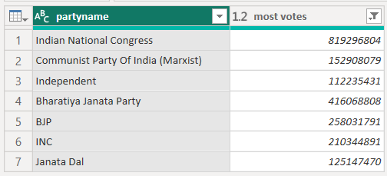

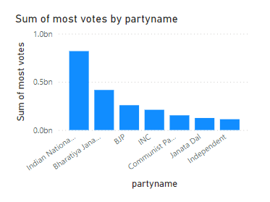

3) How has the overall performance of the top 8 political parties evolved over time in terms of total votes received?

**Solution:**

At the transform data, party name and year group by based on sum of votes_recieved and then apply visual.

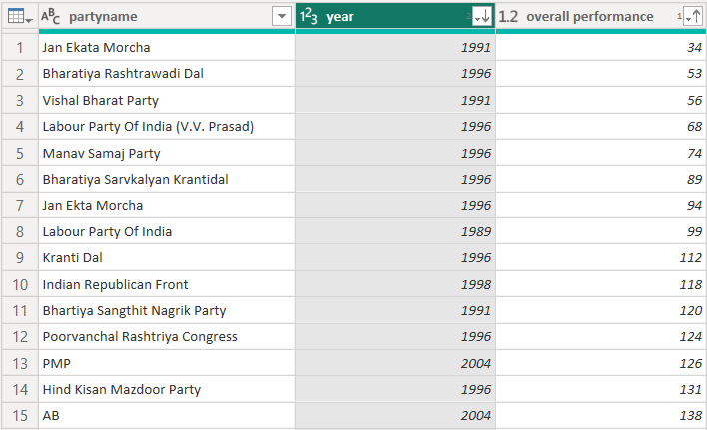

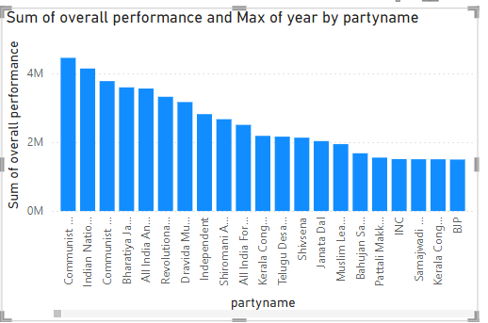

4) Which state had the highest voter turnout in each election year, and how does voter turnout vary across different states?

**Solution:**

At the transform data , st_name , year group by based on the highest voter_received and then apply visual.

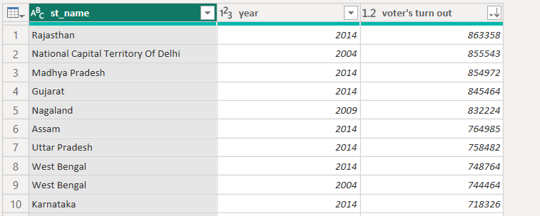

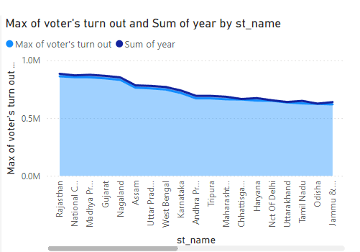

5) Which state had the highest number of candidates contesting in a particular year, and how did it affect voter turnout and election results?

**Solution:**

At the transform data , st_name , year group by based on the highest voter_received and then apply visual.

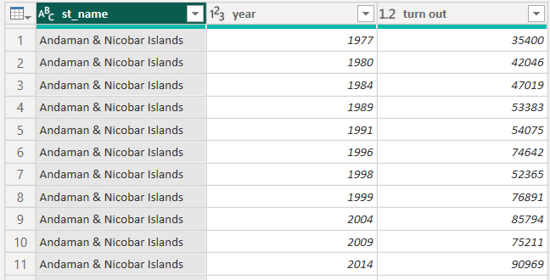

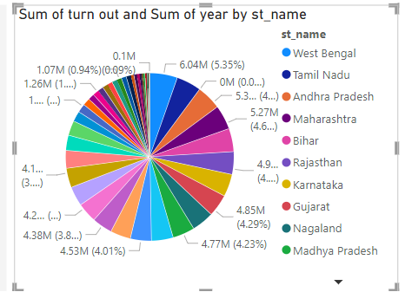

6) Which state had the highest and lowest votes received by a party in a given year? What does this reveal about state-level party dominance?

**Solution:**

At the transform data , st_name , year and party_name group by based on the highest voter_received and lowest voter_received and then apply visual.

**Highest:**

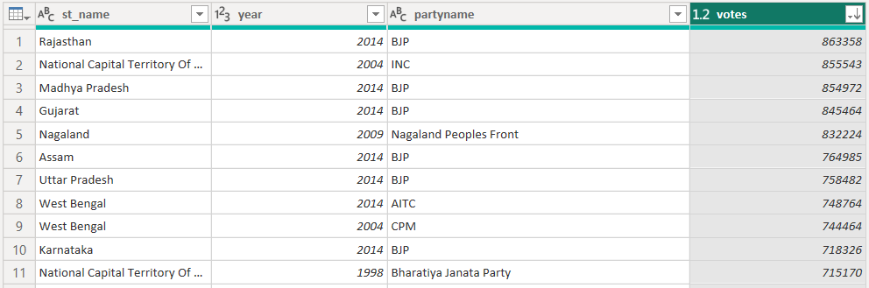

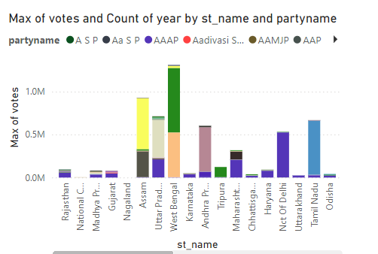

**Lowest:**

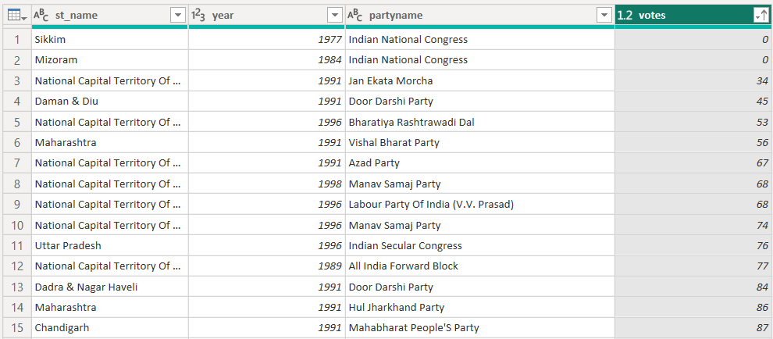

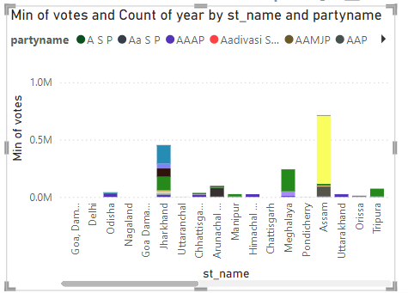

7) Which parliamentary constituency had the highest voter turnout in a specific year, and what factors contributed to this high turnout?

**Solution:**

At the transform data , pc_no , year group by based on the highest voter_received and then apply visual.

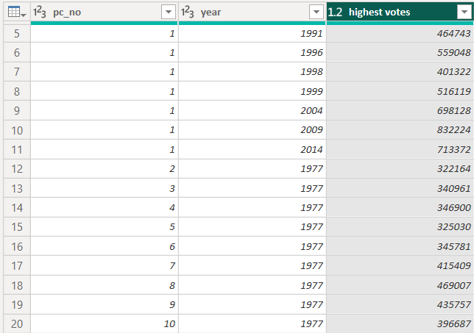

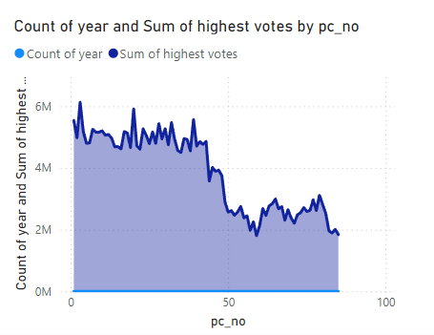

8) How do reserved constituencies compare to unreserved constituencies in terms of votes received by candidates and voter turnout?

**Solution:**

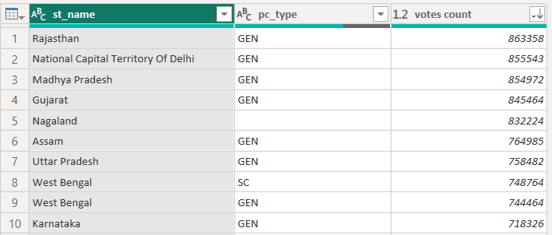

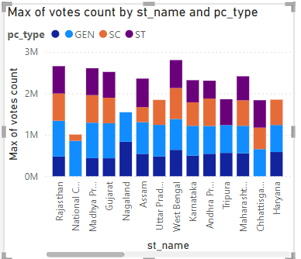

9) Did the reservation status of a constituency (SC/ST/General) affect the election results and voter turnout?

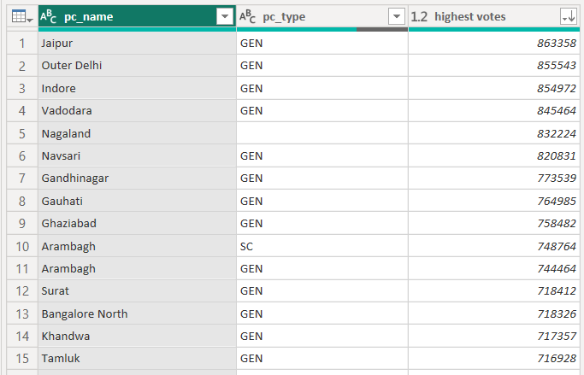

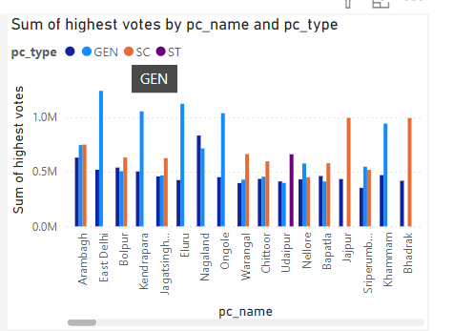

10) Who were the winning candidates in each constituency for each election year, and how many votes did they receive?

**Solution:**

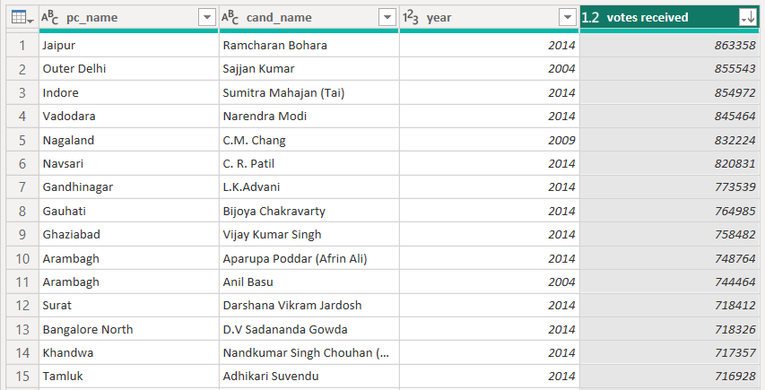

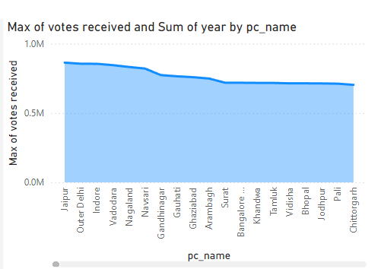

11) Who are the top-performing candidates in terms of total votes received, and which parties do they represent?

**Solution:**

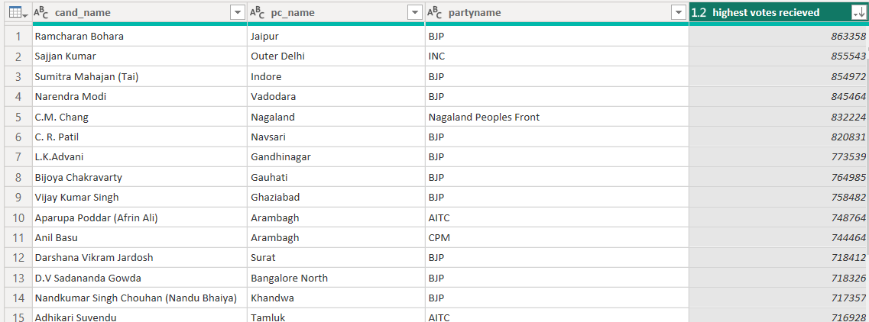

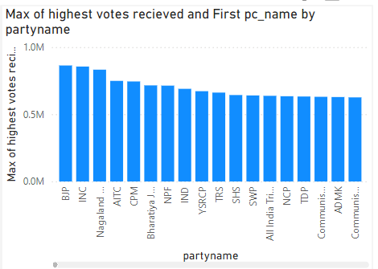

12) How has the performance of winning candidates evolved in constituencies over multiple elections?

**Solution:**

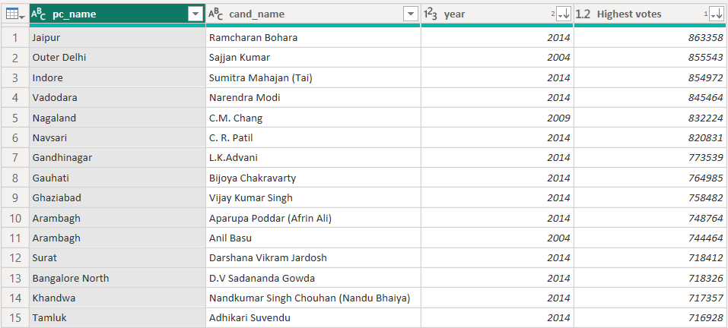

13) What is the gender distribution of candidates over the years, and how has this changed in recent elections?

**Solution:**

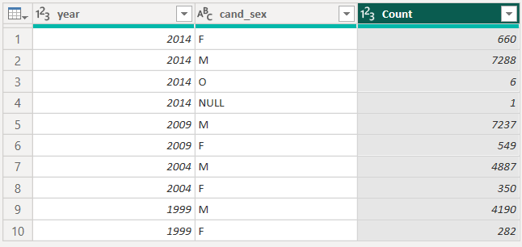

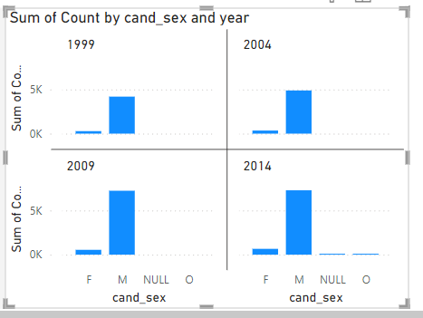

14) How do male and female candidates compare in terms of votes received and winning margins?

**Solution:**

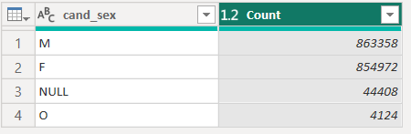

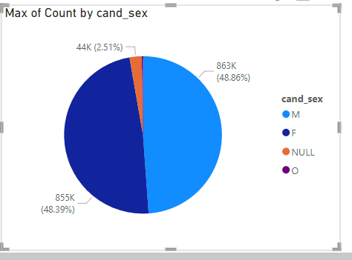

15) What is the overall voter turnout trend over the years, and how does it correlate with the performance of major political parties?